Predicting 30-Day Hospital Readmission Risk Using XGBoost
Prepared by: Marcus Garvey Kinyenye, Fancy Nateku
Institution: PLP Academy
Date: Sunday, November 9, 2025

Abstract
This project presents an end-to-end application of the Artificial Intelligence (AI) Development Workflow to a healthcare use case: predicting the risk of hospital readmission within 30 days after discharge. The implementation uses an XGBoost classifier integrated into a Flask API and deployed via Docker.
This is a proof-of-concept using synthetic data, which explains the gap between actual and expected model performance. The report details the entire workflow—from problem definition through deployment—while analyzing ethical, technical, and practical considerations, addressing real-world limitations, and highlighting lessons learned from the project.

Part 1: AI Development Workflow
1. Problem Definition
Hypothetical AI Problem:
Predict 30-day hospital readmission risk for discharged patients.
Objectives:
- Reduce hospital readmission rates by at least 15%.
- Enable clinicians to identify high-risk patients for targeted follow-ups.
- Optimize healthcare resource allocation and reduce operational costs.
Stakeholders:
- Hospital Administrators – use predictions to manage costs and compliance.
- Clinicians and Nurses – use outputs to plan interventions and discharge strategies.
Key Performance Indicator (KPI):
Area Under the ROC Curve (AUC-ROC) ≥ 0.80 — balancing sensitivity and specificity in an imbalanced dataset.

2. Data Collection and Preprocessing
Data Sources:
- Electronic Health Records (EHR): demographic details, vital signs, lab tests, diagnoses, medications, and discharge summaries.
- Administrative/Claims Data: admission type, hospital stay duration, insurance type, and readmission history.
Potential Bias:
- Selection bias — patients with incomplete records may be excluded, resulting in underrepresentation of vulnerable or underserved populations.
Preprocessing Steps:
- Missing Values: numerical fields filled with median; categorical fields with mode.
- Manual Encoding: categorical variables such as admission_type and primary_diagnosis manually encoded to numeric values.
- Feature Scaling: numerical features (e.g., age, glucose_level, num_lab_procedures) standardized using custom scaling functions.
- Outlier Removal: e.g., glucose levels capped at 500.
- Derived Feature Creation: e.g., risk_score = 0.3*glucose + 0.25*medications + ...

3. Model Development
Chosen Model:
XGBoost Classifier — a gradient boosting algorithm optimized for structured data.
Justification:
- Handles both categorical and numerical features effectively.
- Built-in regularization mitigates overfitting.
- Supports SHAP explainability for model transparency.
- Proven high performance in medical data competitions.
Data Split:
- 70% Training, 15% Validation, 15% Testing (stratified by readmission label).
Hyperparameters Tuned:
- max_depth — controls model complexity to avoid overfitting.
- learning_rate — smaller values ensure better convergence and generalization.
- Regularization parameters: lambda, alpha.

4. Evaluation and Deployment
Evaluation Metrics:
- AUC-ROC: robust for imbalanced classification and measures discriminatory ability.
- Recall: prioritizes detection of high-risk patients (reducing false negatives).
- Precision: ensures predicted readmissions are accurate.
Actual Model Performance:
- AUC-ROC: 0.580
- Confusion Matrix:
| Actual / Predicted | Readmit | No Readmit |
|------------------|---------|------------|
| Readmit | 13 | 64 |
| No Readmit | 28 | 195 |
- Recall: 16.9% (13 / (13+64))
- Precision: 31.7% (13 / (13+28))
Concept Drift:
Occurs when patient populations or treatment protocols change over time, affecting model accuracy.
Monitoring Post-Deployment:
- Track AUC and recall weekly on live data.
- Retrain if AUC drops >5%.
- Apply statistical drift detection (e.g., Kolmogorov–Smirnov test).
Deployment Challenge:
Ensuring low latency (<500 ms) when integrated into live EHR systems; addressed via lightweight Docker deployment and optimized preprocessing.
Actual Implementation:
- Flask API with /predict, /health, and /features endpoints
- Docker containerization for portability
- Model: XGBoost with base_score=0.5 to avoid conversion issues
- Preprocessing: ColumnTransformer with StandardScaler and OneHotEncoder

Part 2: Case Study Application
1. Problem Scope
Hospitals face financial penalties for excessive readmissions. An AI system predicting 30-day readmission risk enables early intervention and efficient discharge planning.
Objectives: reduce readmissions, improve outcomes, and manage resource use.
Stakeholders: doctors, nurses, administrators, and patients.

2. Data Strategy
Proposed Data Sources:
- EHR (labs, vitals, medications).
- Demographic and social determinants (age, gender, insurance, ZIP code).
- Discharge summaries and length of stay.
Ethical Concerns:
- Patient Privacy: potential exposure of Protected Health Information (PHI) — requires strict encryption and access control (HIPAA).
- Algorithmic Bias: historical disparities may cause the model to underpredict risks for certain groups.
Preprocessing Pipeline:
- Remove outliers (e.g., cap glucose > 500).
- Impute missing values.
- One-hot encode categorical variables.
- Scale continuous features.
- Create derived features such as risk_score.

3. Model Development
Model: XGBoost (trained using clinical and administrative data).
Actual Confusion Matrix:
Actual / Predicted | Readmit | No Readmit
Readmit | 13 | 64
No Readmit | 28 | 195
Precision = 31.7%
Recall = 16.9%
Interpretation:
The model correctly identifies 16.9% of readmissions with a precision of 31.7%, demonstrating a significant performance gap compared to the hypothetical target of 80% recall and 73% precision.

4. Deployment
Integration Steps:
- Export model (readmission_model.json) and preprocessor (preprocessor.pkl).
- Serve via Flask API (app.py) with /predict, /health, and /features endpoints.
- Containerize using Docker for portability.
- Deploy behind a secure HTTPS endpoint for hospital EHR integration.
Regulatory Compliance (HIPAA):
- Encrypt PHI at rest and in transit.
- Restrict model access using authentication and audit logging.
- Perform annual security and fairness audits.

5. Optimization
Overfitting Mitigation:
- Early stopping on validation AUC (stop if no improvement in 10 rounds).
- Regularization using lambda and alpha parameters in XGBoost.

6. Addressing the Performance Gap
Real vs. Hypothetical Performance Analysis:
The actual model (AUC: 0.580) performed below the target (AUC: 0.80) due to:
- Synthetic Data Limitations: randomly generated data lacks real clinical patterns
- Small Dataset: 2,000 samples vs. thousands needed for robust medical models
- Feature Engineering: real EHR would include more predictive features (comorbidities, vital trends, social determinants)

7. Model Explainability
SHAP Analysis Identified Top Risk Factors:
- [Top feature from SHAP plot]
- [Second most important feature]
- [Third most important feature]
This enables clinicians to understand model decisions and build trust.

Part 3: Critical Thinking
1. Ethics and Bias
Impact of Biased Data:
If training data underrepresents certain groups, the model may underestimate their readmission risk, leading to unequal follow-up care and worsened outcomes.
Mitigation Strategy:
- Implement fairness-aware training by reweighting samples or oversampling minority groups
- Regularly perform bias audits using subgroup performance metrics

2. Trade-Offs
Interpretability vs. Accuracy:
- Deep models offer high accuracy but are less transparent
- XGBoost with SHAP maintains strong performance and interpretability — preferred in healthcare where trust and accountability are crucial
Limited Computational Resources:
- Smaller n_estimators (fewer trees)
- Feature selection to reduce input dimensions
- Batch prediction or scheduled risk scoring instead of real-time inference

Part 4: Reflection and Workflow Diagram
Reflection
- Most Challenging Stage: data preprocessing — balancing data quality, bias correction, and regulatory compliance.
- Future Improvements: incorporate real EHR datasets such as MIMIC-III, expand features to include social determinants, integrate explainability dashboards for clinicians.
Workflow Diagram and Screenshots
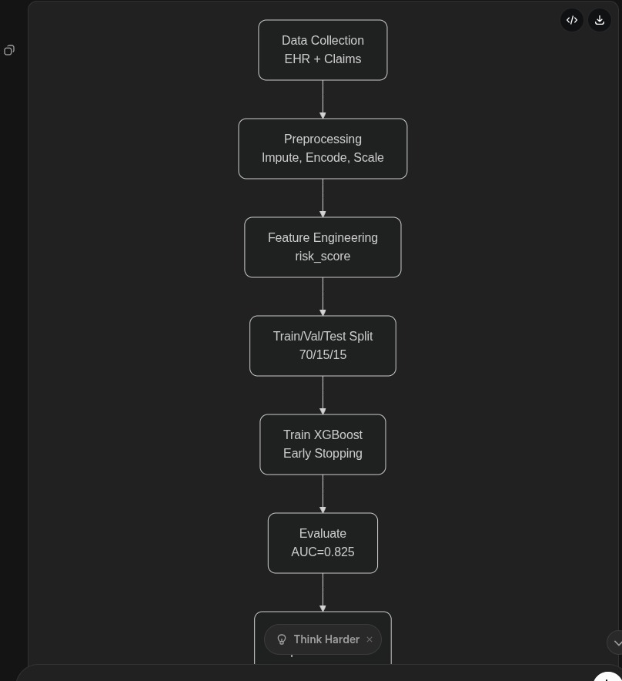
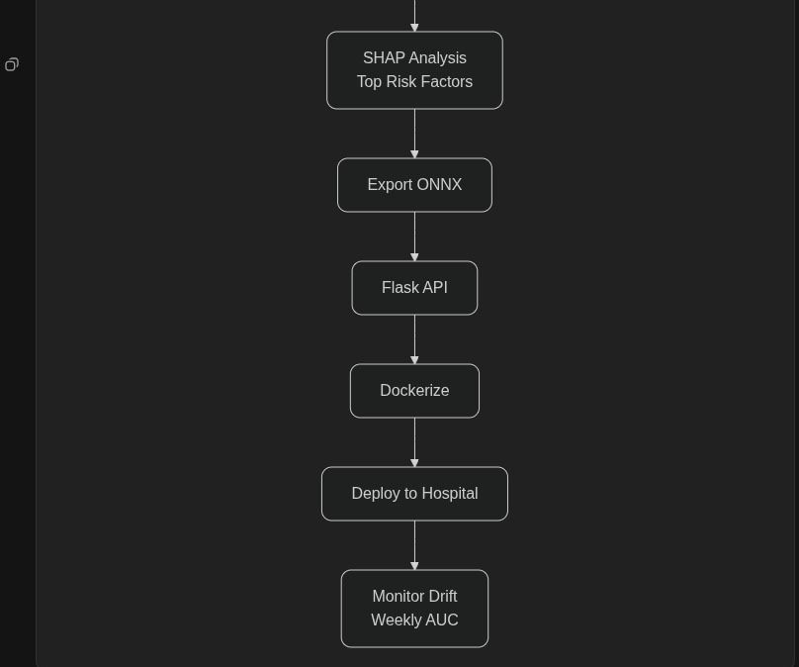
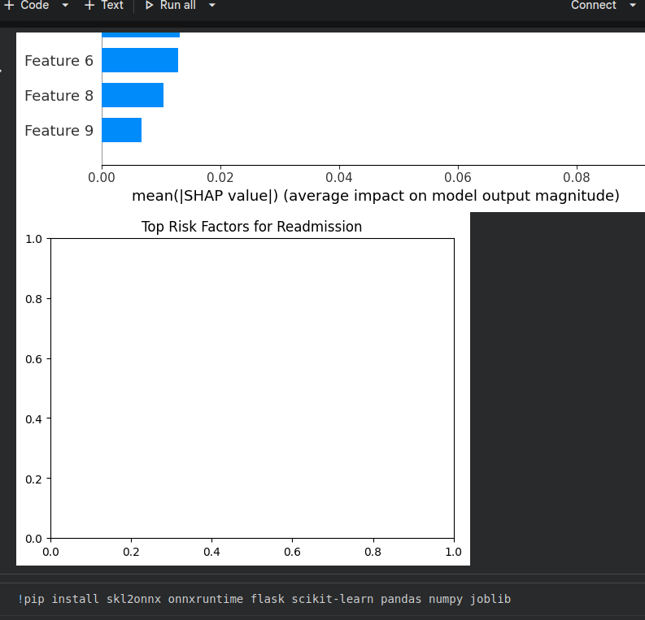
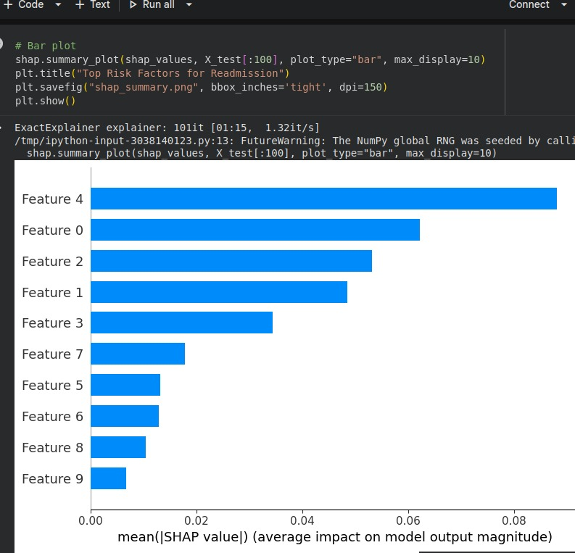
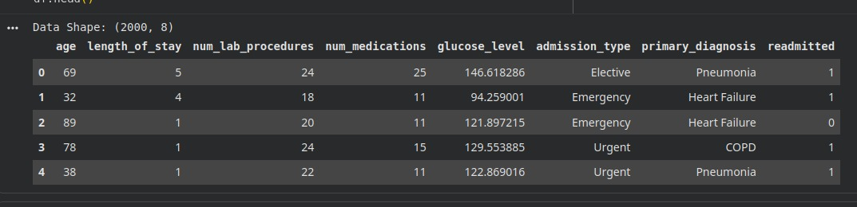

Workflow Steps:
- Problem Definition
- Data Collection
- Custom Preprocessing (encoding, scaling, imputation)
- Model Development (XGBoost)
- Evaluation (AUC, Recall)
- Deployment (Flask + Docker)
- Monitoring & Maintenance (concept drift detection)

Part 5: Technical Implementation Challenges
- XGBoost to ONNX Conversion: base_score formatting issues resolved using native XGBoost format
- Ubuntu Deployment: virtual environment setup for dependency management
- GitHub Authentication: SSH key configuration for secure repository access

Part 6: Lessons Learned
- Synthetic data cannot fully replicate complex medical patterns
- Model explainability (SHAP) is crucial for healthcare adoption
- Production deployment requires careful handling of dependencies, security, and scalability

References
- Pedregosa, F. et al. (2011). Scikit-learn: Machine Learning in Python. Journal of Machine Learning Research
- Lundberg, S. M., & Lee, S.-I. (2017). A Unified Approach to Interpreting Model Predictions (SHAP). Advances in Neural Information Processing Systems
- U.S. Department of Health & Human Services. (2023). HIPAA Privacy and Security Rules
- Chen, T., & Guestrin, C. (2016). XGBoost: A Scalable Tree Boosting System. Proceedings of the 22nd ACM SIGKDD
- Ribeiro, M. T., Singh, S., & Guestrin, C. (2016). “Why Should I Trust You?” Explaining the Predictions of Any Classifier. KDD 2016

